**COMPUTER NETWORK LAB MST**



**Student Name: ADITYA SHINDE UID: 19BCS3548**

**Branch: CSE IBM IS1 Section/Group: B**

**Semester: 4TH Date of Performance: 22 MARCH,2021**

**Subject Name: CN LAB Subject Code: 21 E CSP-293**



1. **Aim/Overview of the practical :**

De**sign and Configure Routing Information Protocol using 3 routers.**

1. **Task to be done:**

Setup virtual network connecting 3 Routers along with RIP in CISCO PACKET TRACER SOFTWARE

**3.) Software Requirement: Cisco Packet Tracer**

**4.) Theme/Interests definition ( For creative domains):** 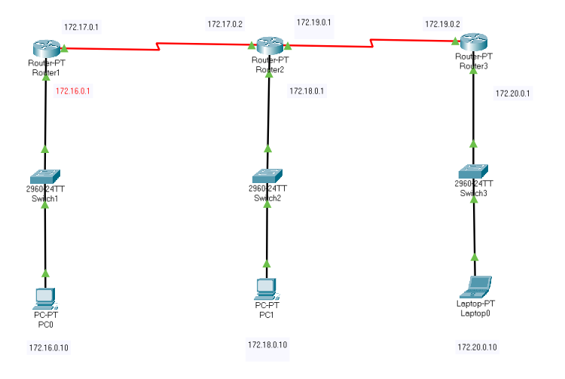

**Router: -** It is a device which used communicate three devices. It works under network layer of OSI model.

**RIP: -** Routing Information Protocol (RIP) is a dynamic routing protocol which uses hop count as a routing metric to find the best path between the source and the destination network.

**5. Steps/Configurations:**

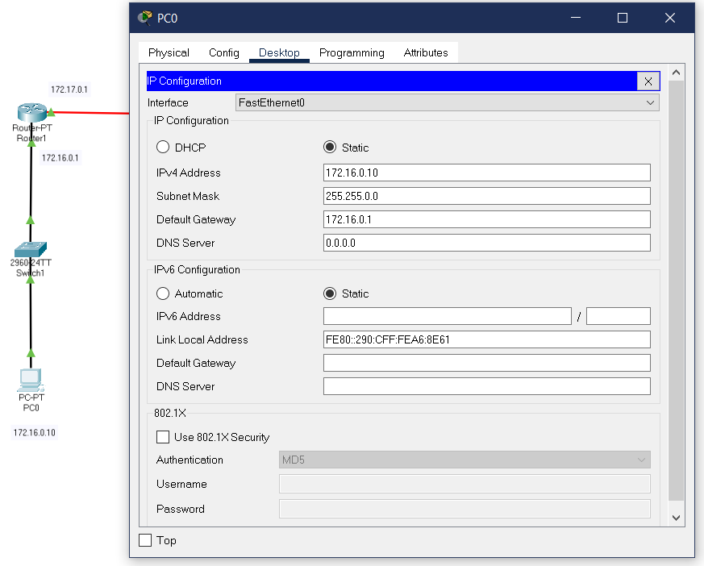

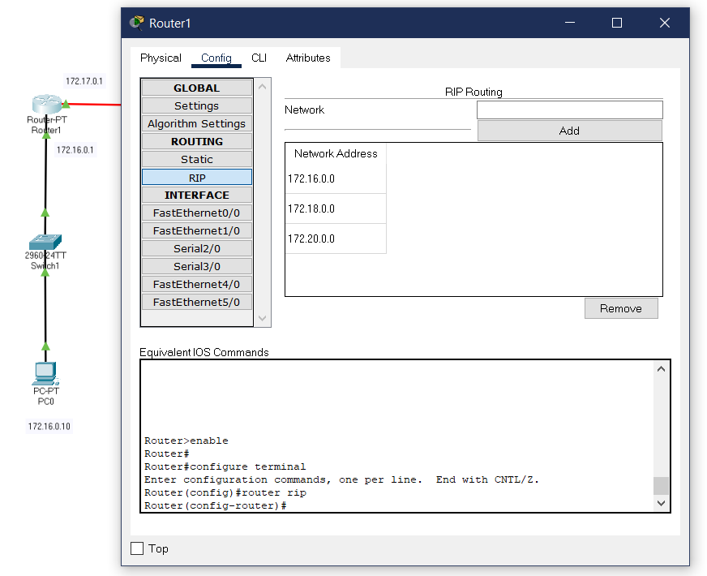

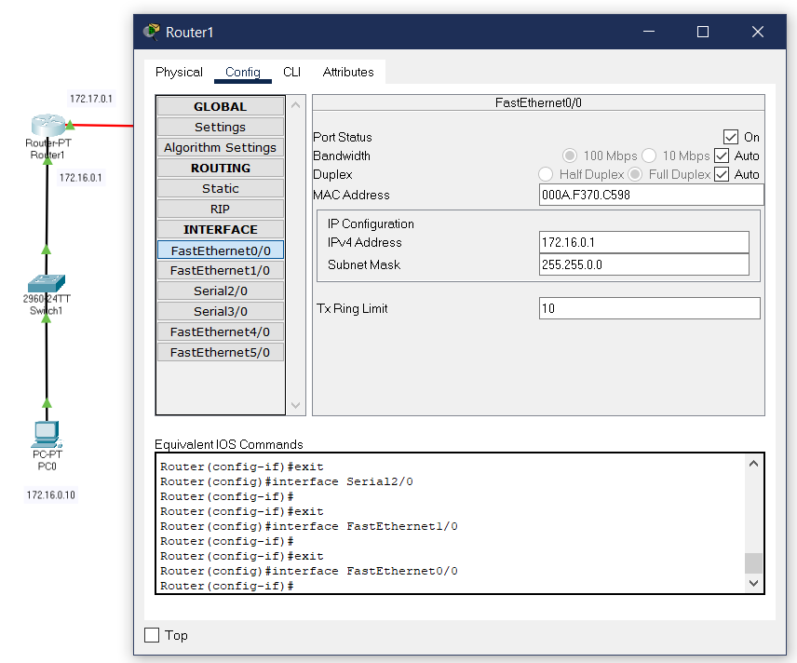

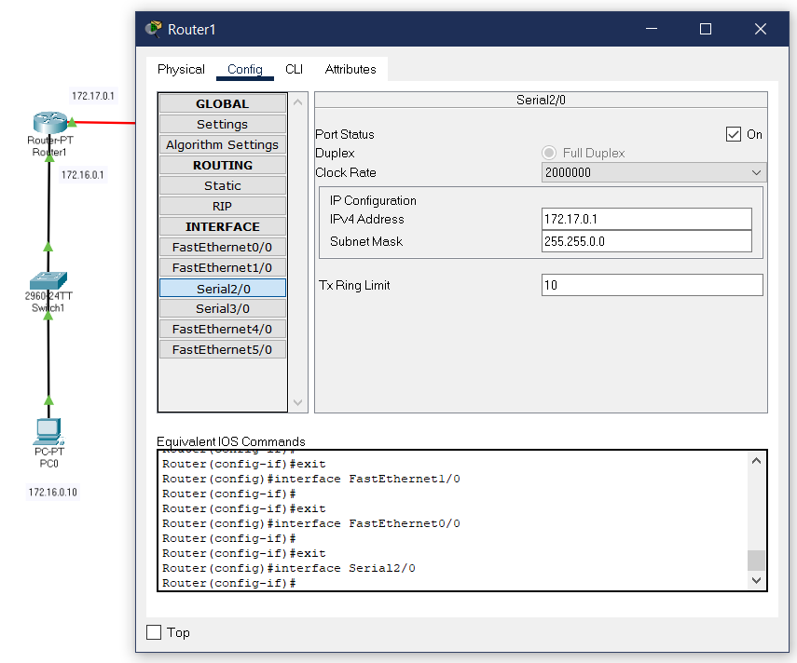

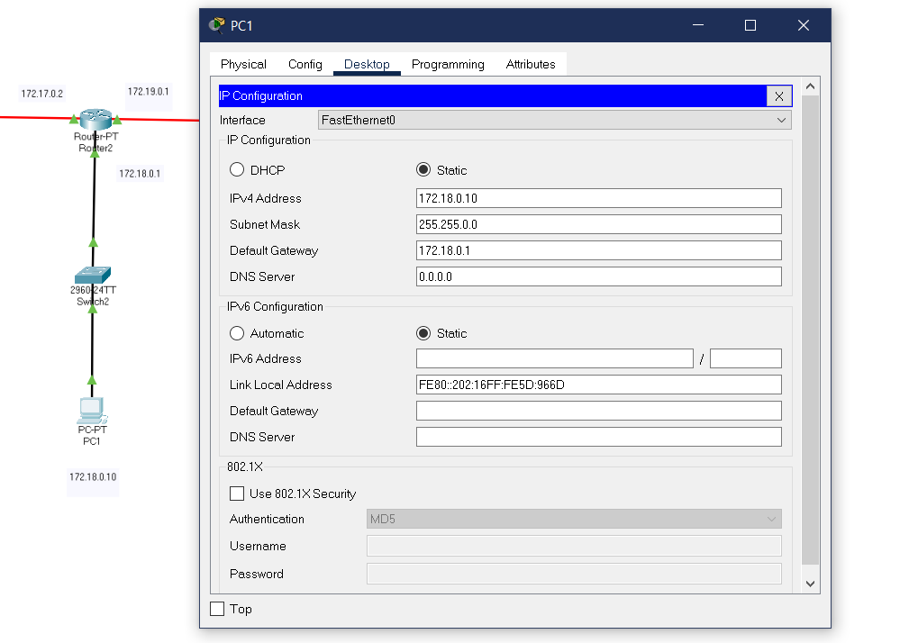

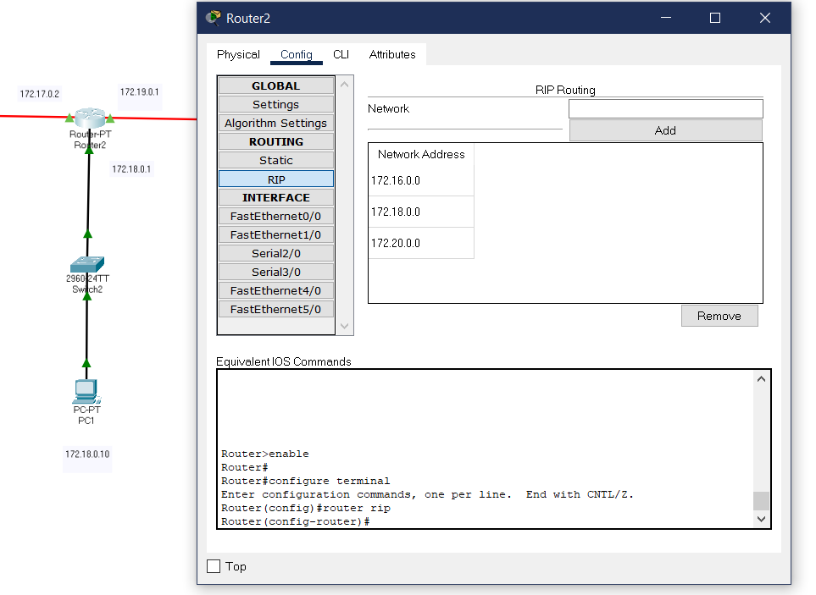

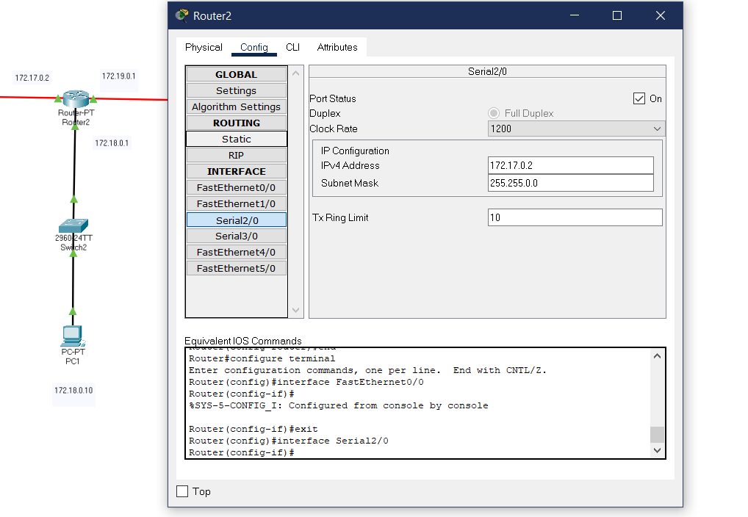

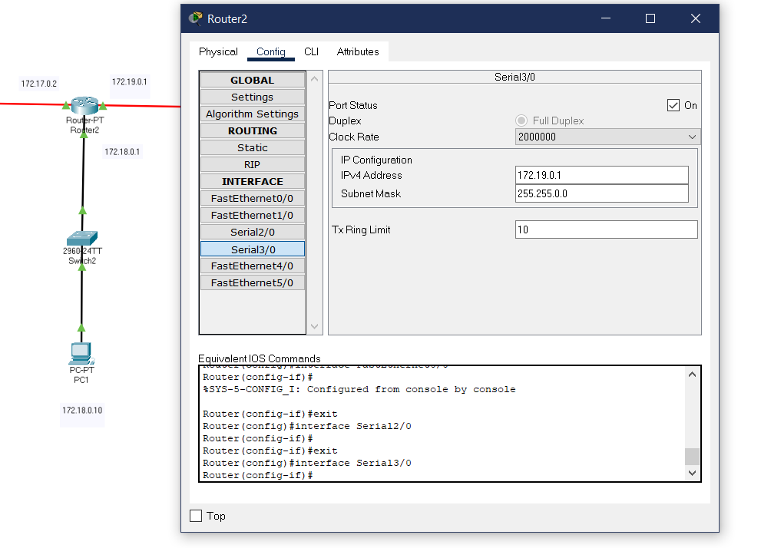

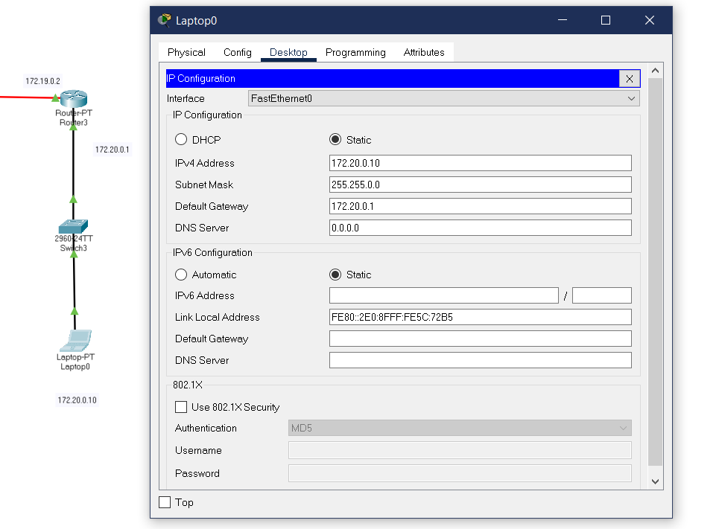

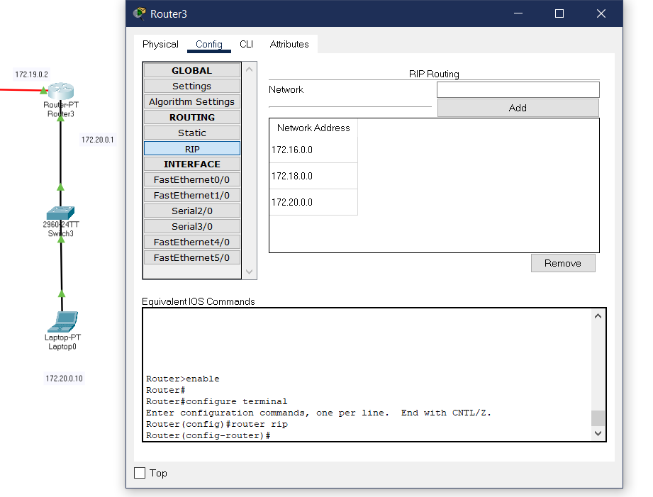

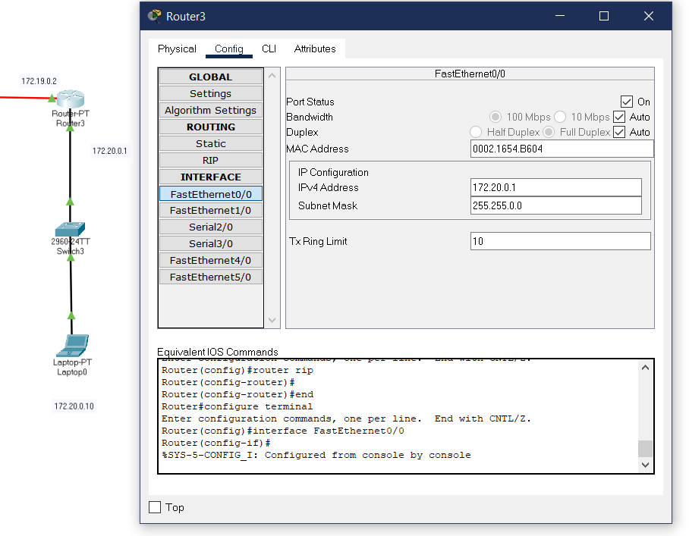

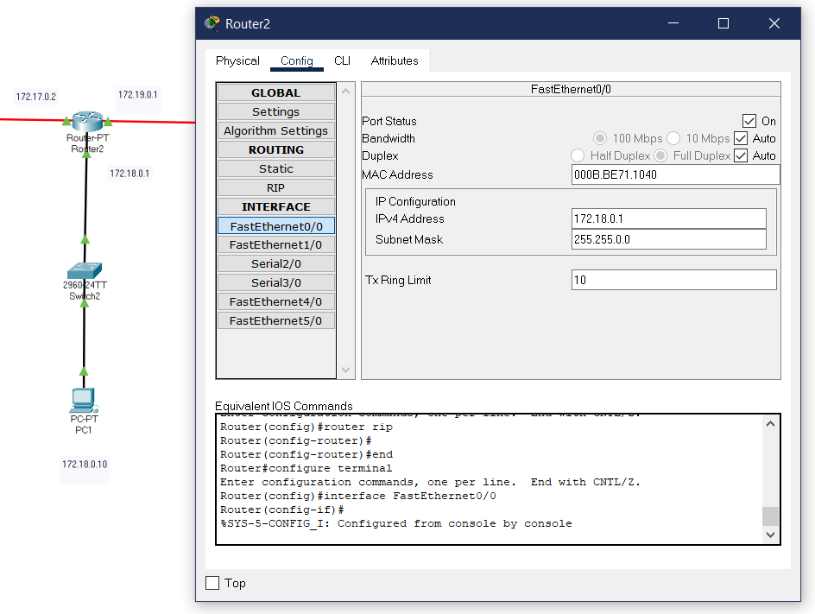

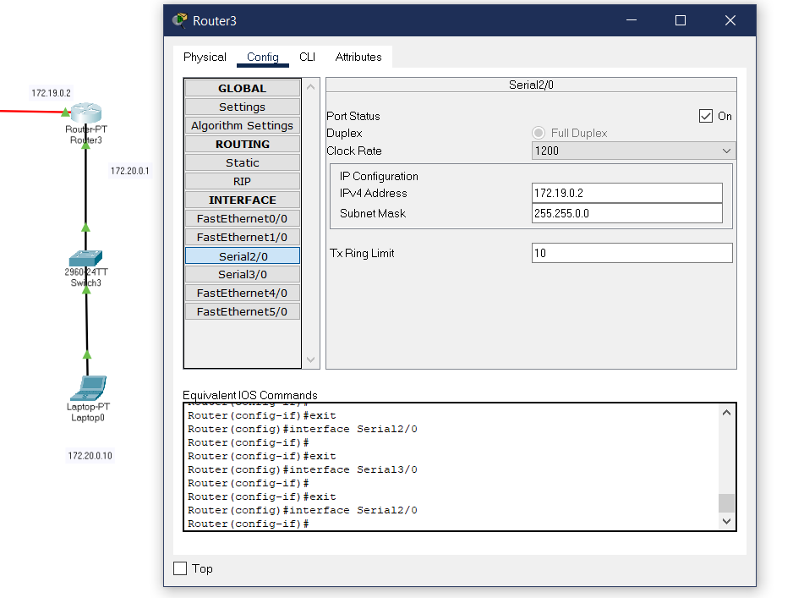

1. **Result/Output:**

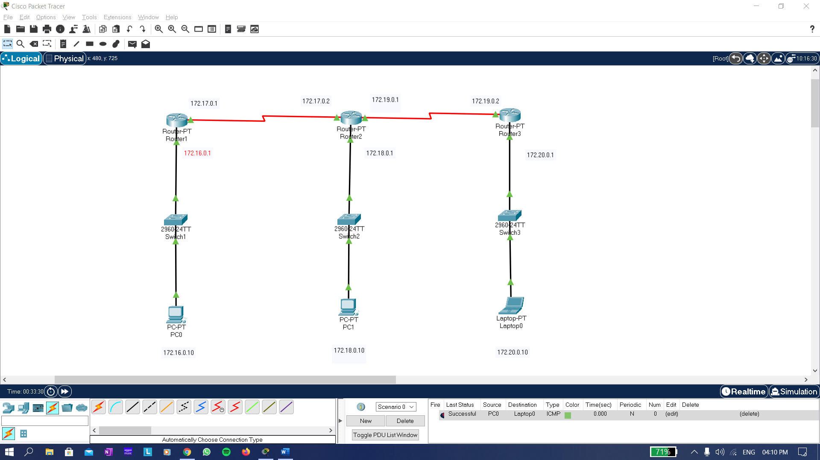

**Learning outcomes (What I have learnt):**

* Inthis practical I learn how network packet tracer work.
* In this practical I learn how to Configure three routers.
* In this practical I learn about RIP.
* In this practical I learn about the packet transfer from one network to another.

**Link to the working file:**

**Evaluation Grid (To be created as per the SOP and Assessment guidelines by the faculty):**

|  |  |  |  |
| --- | --- | --- | --- |
| Sr. No. | Parameters | Marks Obtained | Maximum Marks |
| 1. |  |  |  |
| 2. |  |  |  |
| 3. |  |  |  |